**Patient Health Monitoring System**

**Subject:** Cloud Computing

**Name:** Amit Kumar Sahu

**Reg. No.:** 18MIS7250

**Dated:** 10th June 2021

**ABSTRACT**

The cloud computing technologies are progressively permitting to coordinate gadgets fit for associating with the Internet and give data on the condition of health of patients and give data continuously to specialists who help. The main aim of this ‘Health Care Monitoring System’ or ‘Patient Monitoring System’ is to build up a system fit for observing vital body signs, for example, body temperature, heart rate, pulse oximetry. To accomplish this, the system involves many sensors to screen fundamental signs that can be interfaced to the doctor’s mobile or the web. The gadget (Smart watch) will exchange the readings from the sensor to cloud remotely and the information gathered will be accessible for analysis progressively. It has the capacity of reading and transmitting emergency signs to the cloud and then to doctor’s web portal or to Doctor’s Smartphone. These readings can be utilized to recognize the health state of the patient and as an alert system against the emergency health condition.

**INTRODUCTION**

Health Care Monitoring System can be characterized as the system utilized for observing physcological signs that incorporate the parameters like the body temperature, heart rate and SpO2 Oximeter. Understanding and checking monitoring system is crucial during the critical conditions of patients. These systems are utilized for the practice of medicinal and general health with the assistance of cell phones and web applications. Patient monitoring is relevant in various circumstances when a patient is in the accompanying conditions:

* In such conditions where the oxygen level of patient is not normal.
* During this pandemic it’s very crucial to check the oxygen level and heart beat rate to check on the patient and take necessary steps to stabilize it.
* In a life-threatening condition – for instance, when there is an indication of heart attack in a patient.
* In a situation leading to the developing of a risky life-threatening condition.
* In a critical physiological state

These days, the health care sensors are playing a fundamental part in hospitals. The patient checking monitoring is one of the significant improvements as a result of its creative innovation. A programmed remote health observing system is utilized to quantify patient’s body temperature, pulse by utilizing implanted innovation. The proposed system utilizes sensors like pulse sensor, oximeter and temperature sensor. These sensors mostly include in observing the health condition, fall detection and sleep pattern of the patient.

**PROPOSED SYSTEM**

This system continuously monitor’s the patient’s body temperature, SpO2 and heart beat rate. The data then is sent to cloud within a timespan of one minute. There are some parameters that are kept in consideration as a built-in alert system in the device as well as cloud. These parameters are:

For body temperature:

|  |  |
| --- | --- |
| Temperature | Causes |
| <25 Degree Celsius | Low |
| >42 Degree Celsius | High |
| 37 Degree Celsius | Normal |

For oximeter:

|  |  |  |
| --- | --- | --- |
| SpO2 Level | Indication | Healthcare Intervention |
| Normal in healthy individual | >= 90% | No Significant intervention needed |
| Normal in people of COPD | 88% - 90% | Continue with respiratory assessment |
| Hypoxic | 85% - 94% | Check for respiratory disease and initiate oxygen therapy |
| Several Hypoxic | <85% | Administer Supply Oxygen immediately |

For heartbeat rate:

|  |  |
| --- | --- |
| Heart Beat | Causes |
| <60bpm | Low |
| >20bpm | High |
| 60-120bpm | Normal |

Since it is a situation of life and death if patient is in critical condition so we have Multi-Datacenter Architecture. So, if in case one of the data center fails we can still monitor patient’s health continuously.

If there is any state of emergency then the system send alert on the doctor’s or any other concerned authority a ring call and a message as well regarding the patient’s health condition.

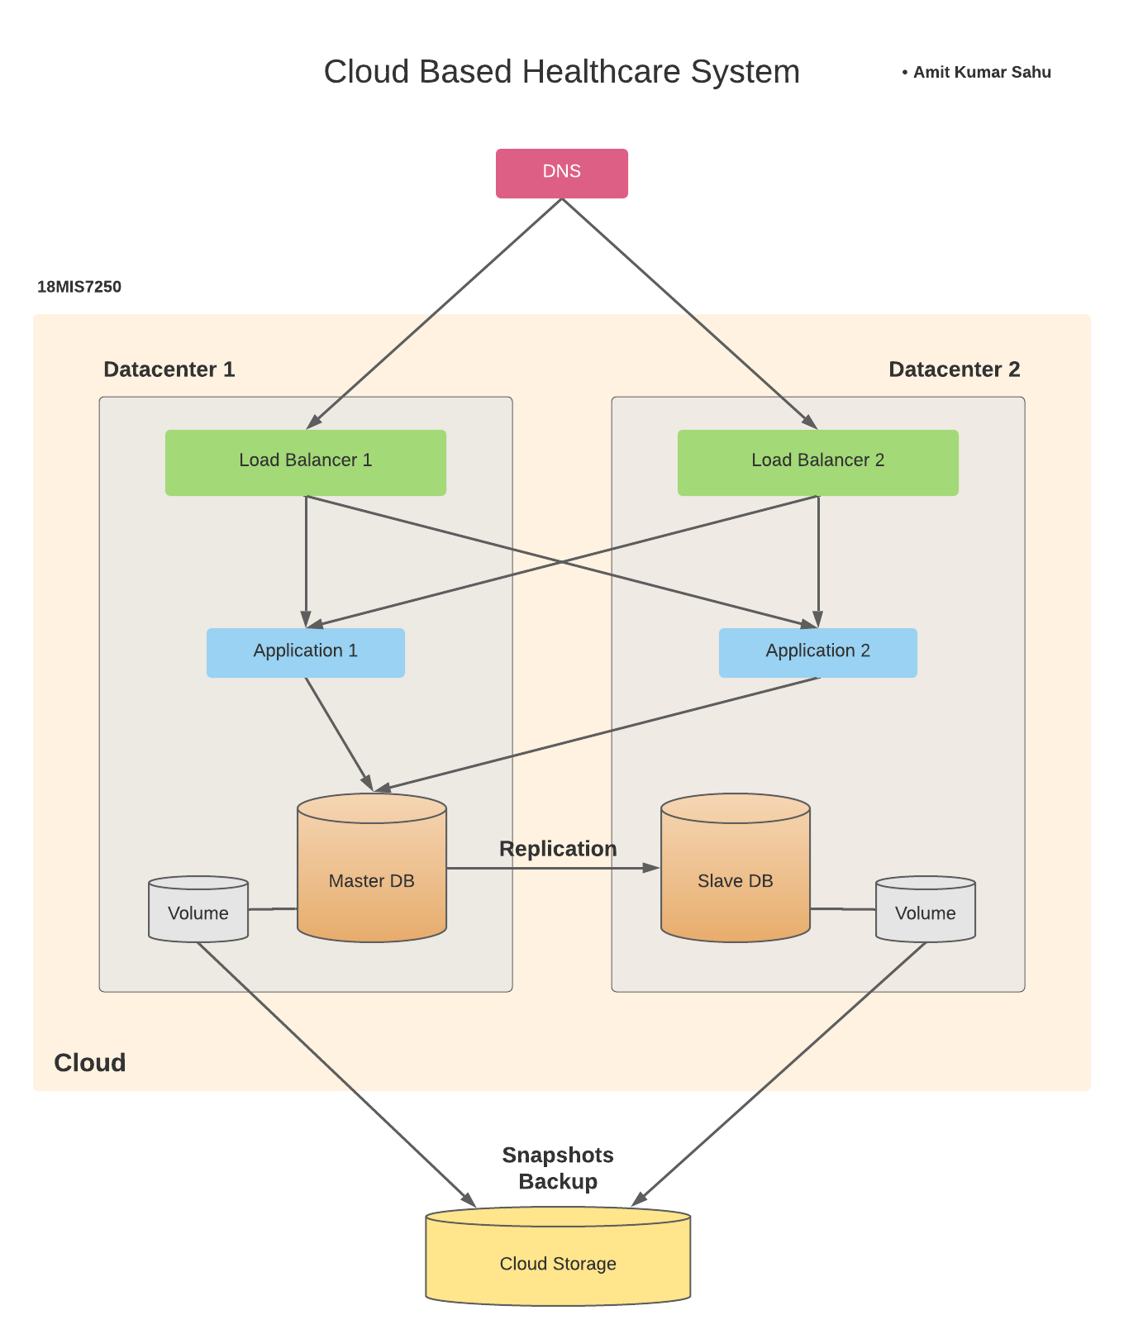

Above figure shows how we can implement multi-datacenter architecture.

Since our cloud infrastructure supports multiple datacenters (or zones), it's recommended that we spread your system architecture across multiple datacenters to add another layer of redundancy and protection. Each datacenter in a cloud is designed to be an isolated segment inside the same geographical cloud. So if a power failure occurs in one datacenter, the other datacenters will be unaffected. For example, within a cloud/region there may be several resource pools called availability zones and datacenters. The benefit of using multiple datacenters is to protect our entire site/application from being negatively affected by some type of network/power failure, lack of available resources, or service outtage that's specific to a particular datacenter.

As a best practice we should always leverage multiple datacenters in our architecture if they are supported by the cloud infrastructure.

**CLOUD HOSTING PLATFORM**

The whole system can be hosted on the Amazon Web Services (AWS) Cloud.

**AWS:** AWS IoT is a managed cloud platform that lets connected devices easily and securely interact with cloud applications. AWS IoT provides authentication and end to-end encryption throughout all points of connection, so that data is never exchanged between devices and AWS IoT without proven identity. Thus, data is securely being transmitted to the AWS IoT platform through MQTT protocol. AWS helps the data to be stored in the DynamoDB database and the data can then be used for sleep pattern analysis. In case of emergency it helps in sending mobile notifications to the relatives and doctors of the patient.

* **Broad and deep**

AWS has broad and deep IoT services, from the edge to the cloud. AWS IoT is the only cloud vendor to bring together data management and rich analytics in easy to use services designed for noisy IoT data.

* **Multi-layered security**

AWS IoT offers services for all layers of security, including preventive security mechanisms, like encryption and access control to device data, and a service to continuously monitor and audit configurations.

* **Superior AI integration**

AWS brings AI and IoT together to make devices more intelligent. You can create models in the cloud and deploy them to devices where they run 2x faster compared to other offerings.

* **Proven at scale**

AWS IoT is built on a secure and proven cloud infrastructure, and scales to billions of devices and trillions of messages. AWS IoT integrates with other AWS services, so you can build complete solutions.

**AWS IoT services**

* **Device software**

Connect your devices and operate them at the edge.

* **Connectivity & control services**

Secure, control, and manage your devices from the cloud.

* **Analytics services**

Work with IoT data faster to extract value from your IoT data.

**USER INTERFACE DESIGN**

The user interface contains:

* Home Screen: Patient’s Information
* Error Screen: Not connected to internet/Not syncing
* Weekly alert screen: Total alerts in a last week
* Temperature Screen: Checks body temperature
* SpO2 Screen: Checks SpO2 level and oxygen Level
* Heart Beat Rate Screen: Monitors BPM of the patient

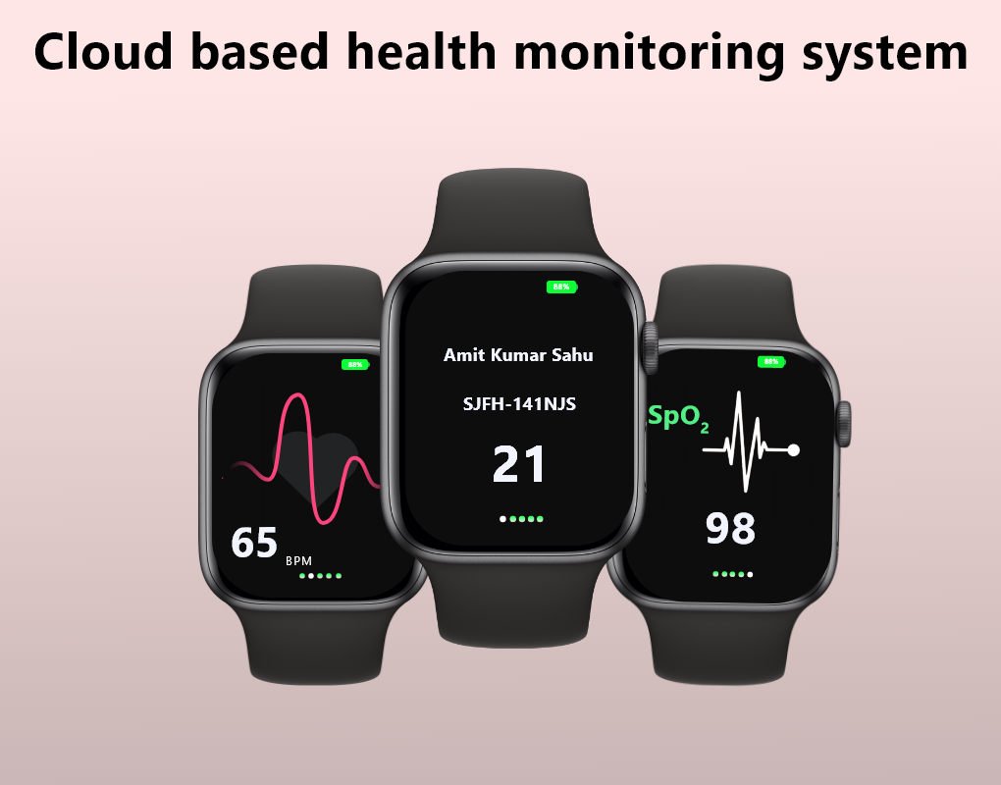

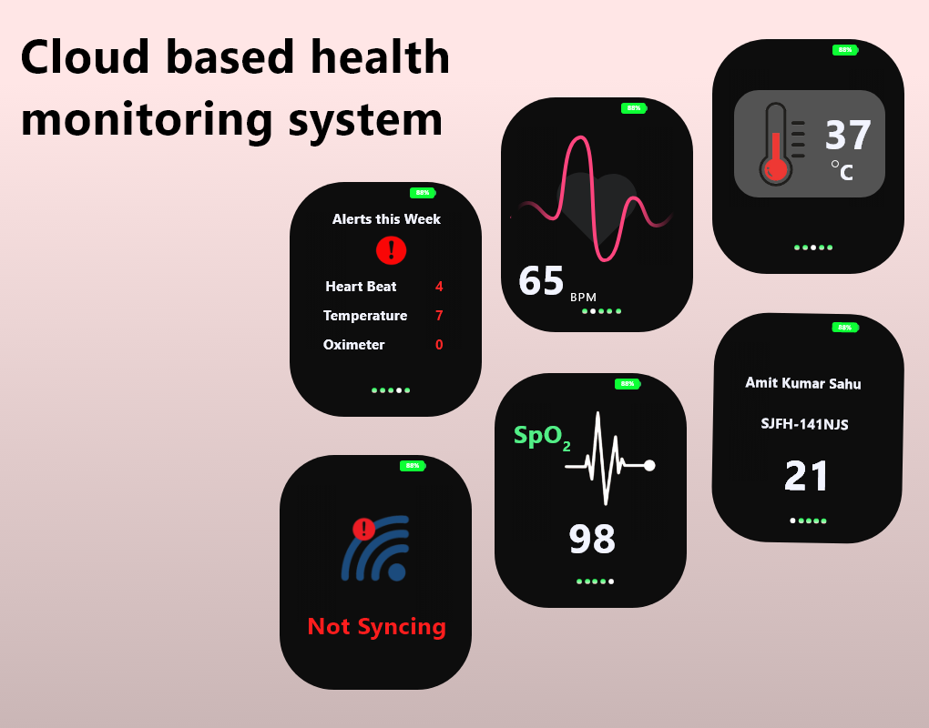

**SYSTEM SCOPE**

Further we can implement Machine Learning algorithms for health state prediction.

Analysis of the dataset can be done by using machine learning approach. A classification technique (or classifier) is a systematic approach for building classification models from an input data set. Few examples for machine learning algorithms include decision tree classifiers, rule-based classifiers, adaboost classifiers, neural networks, support vector machines, least squares regression, Knn classifier and Naive Bayes classifiers. Each technique provides a learning algorithm to recognize a model that best fits the bond between the attribute set and class label of the given input data. The model generated by a learning algorithm should be able to fit the input data well and also correctly foretell the class labels of records it has never seen before. The key objective of each learning algorithms is to build models with good generalization capability. Using the machine learning algorithms, the dataset for health monitoring is trained and analysis is done based on the training. The classifier used in this approach is K-Nearest Neighbor classifierA.K-NearestNeighbour(KNN)classifier:Knn is a non-parametric supervised learning technique in which the data is classified to a given category with the help of training set. Predictions are made for a new instance (x) by searching through the entire training set for the K most similar cases (neighbors) and summarizing the output variables for those K cases. In the classification, this is the mode class value. Its purpose is to use a database in which the data points are separated into several classes to predict the classification of a new sample point. The steps of classification are as follows:

**1. Training phase:** a model is constructed from the training instances. The classification algorithm finds relationships between predictors and targets. The relationships are summarized in a model.

**2. Testing phase:** test the model on a test sample whose class labels are known but not used for training the model.

**3.Usage phase:** use the model for classification on new data whose class labels are unknown

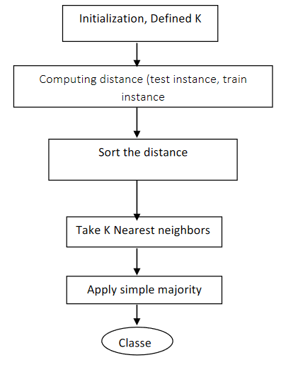

**CONCLUSION**

Health factors of human if left unnoticed will result in serious issues and even cause danger to their life. Automating the continuous monitoring of heath parameters through IoT and Cloud computing is discussed as novel solution

Technology plays the major role in health care not only for sensory devices but also in communication, recording and display device. It is very important to monitor various medical parameter sand post operational days. Hence the latest trend in Healthcare communication method using IOT, Cloud computing and Machine learning techniques.

For this kind of IoT platform based continuous monitoring of human heath parameters, Cloud Computing had played a significant role.

**REFERENCES**

[https://www.engineersgarage.com/what-is-gsm-gprs-module](https://www.engineersgarage.com/what-is-gsm-gprs-module%20)

<https://en.wikipedia.org/wiki/Systems_design>

<https://scholar.google.com/citations?user=Y4opLB8AAAAJ&hl=en>

<https://www.tutorialspoint.com/uml/uml_standard_diagrams.html>